Mechanical insulation
The insulation called mechanical insulation is the material typically placed on the mechanical system equipment in facilities. Once applied it becomes a forgotten and forgone conclusion it will always be intact and performing its intended purpose. That is not the typical result of these systems that are studied and examined. The neglect, aging and abuse has a profound impact on the insulation integrity and also on its ability to do its role.
The emphasis on energy saving and being ”green” such as lighting retrofits and compressor remodels have much more of the glamour and the capital to proceed. The insulation systems on mechanical equipment within a structure can have a dramatic impact on the operating cost budget of a facility.
To put this all in perspective then, wouldn’t a tool that can examine and show emphatically the condition of the insulation systems in respect to energy efficiency be a great and wonderful tool?
Well it’s here and it’s the Thermal or infrared imaging camera. This is a simple handheld instrument that can see heat, the very same energy that the system is designed to not show or reduce for efficiency and energy saving.
The mage interpretation, once learned, can turn a system inspection into a checklist of overall integrity or create detailed repair identification.
The imager has the ability to inspected large sections of the insulation installation at one time. The effect of the image is to compare areas of interest and recognize the patterning that is produced by those areas of compromised insulation.
The image interpretation is the learned skill based on the understanding of heat transfer from the equipment through the insulation and then radiating from final surface.

A couple examples will show what we mean.

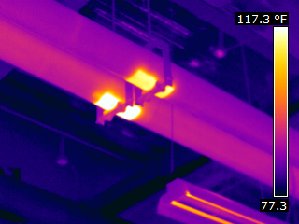

Energy loss from the hanger saddles not insulated.

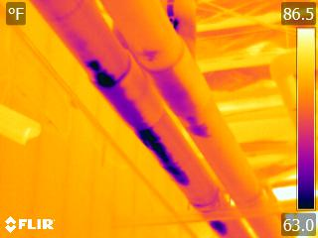

Moisture intrusion into the insulation. Reducing its effectiveness and promoting biological growth.

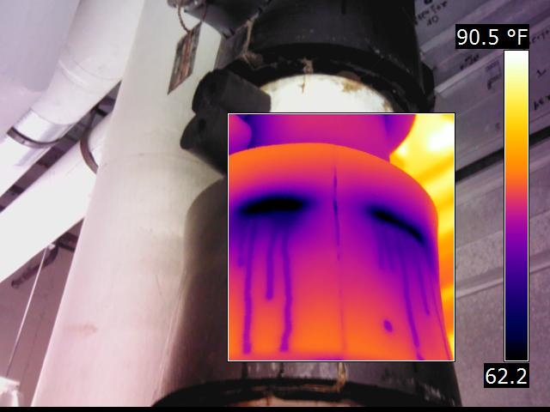

Chilled pipe insulation allowing condensation beneath and now outside of it.

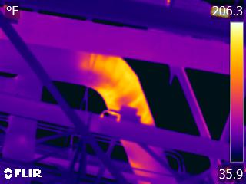

Insulation system failure on an exterior pipe.

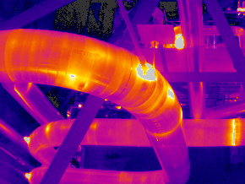

Insulation integrity on an elbow for an exterior steam pipe.

Mechanical insulation inspection will have its caveats and limits to what can and cannot be effectively imaged. Some have to do with the camera functionality such as resolution. Others would be skills such as focusing and tuning of the camera.
The most concerning is the surface that is the last surface presented to the exterior of the system. Bare metal over wraps and protection have a property of low radiant effectiveness s or formally called emissivity. These surfaces can present a seemingly difficult imaging perspective as these surfaces that don’t radiant well will then reflect the environment surrounding that equipment.
A simple solution is to cover those surfaces as much as possible with other material such as thin cloth or tack paper. A more permanent approach is paint area of interest.

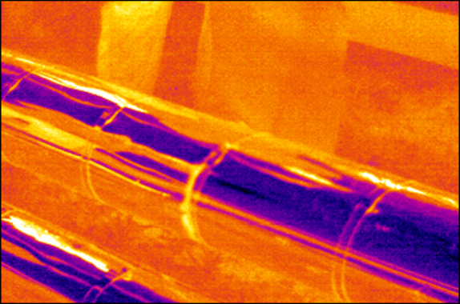
Cold Reflection
Warm Reflection
Cladded Pipes

This is bare metal pipe cover problem as described.

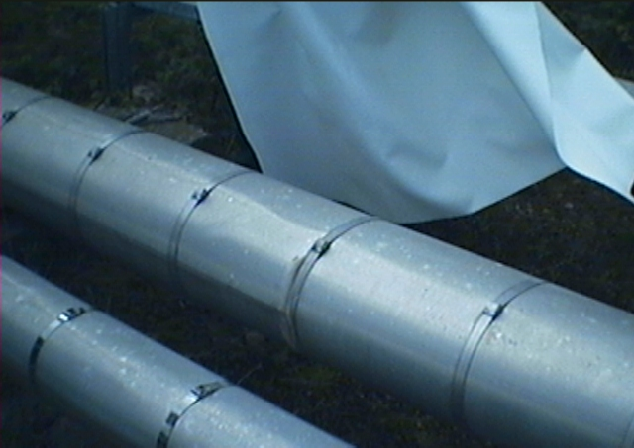

Cover the pipe section with a thin fire blanket to eliminate the low emissive surface.
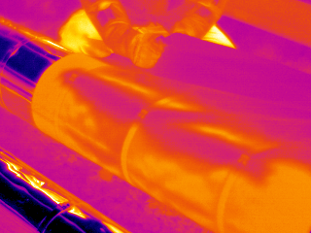

The fire blanket in place and the reflected energy eliminated. The surface can effectively radiant the true pattern of the potential underlying defect.

In summary, the thermal imaging camera presents itself as a tool, when applied and utilized effectively, to inspect and ascertain the overall effectiveness of an insulation system.
The proper training and fundamental of taking measurements can then extend the purpose and function to provide meaningful data for energy calculations.

Jay Bowen
President – Bowen & Associates, LLC
ASNT NDT Level 3 -TTIR

